OFFICIAL COORDINATION REQUEST FOR
NON-ROUTINE OPERATIONS AND MAINTENANCE

COORDINATION TITLE-18BON67 Adult Fish Facility Video Data Collection by Whoosh
COORDINATION DATE-11/01/18
PROJECT- BON
RESPONSE DATE- 11/15/2018

UPDATE 190214: Whooshh returned to FPOM for the February meeting with additional changes to their design.

190322 – Regional partner site visit to the AFF to see the scanner in place.

Description of the problem
Whoosh Innovations would like to install a scanner to photograph fish that pass through the AFF flumes but bypass the sampling tank in order to build algorithms for an automated fish identification system. Please see the attached proposal for details.

Type of outage required

Impact on facility operation (FPP deviations)
The work will be completed during the winter maintenance period when the facility will be dewatered.
Impact on unit priority
None
Impact on forebay/tailwater operation
None
Impact on spill
None

Dates of impacts/repairs
Install winter of 2018/19. Any work done during the sampling season will be scheduled to not interfere with CRITFC sampling.

Length of time for repairs
Whoosh will have the modifications completed prior to water up for CRITFC sampling.

Analysis of potential impacts to fish
This system would provide an estimate of how many fish pass through one of the two AFF bypass flumes. This work is not expected to have impacts on fish. The temporary flume will be similar in shape to the existing exit pipe. From a fish’s perspective, there should be no change in condition.
Should fish exhibit any abnormal behavior BON Fisheries will immediately notify FPOM and a course of action will be determined at that time.

Summary statement - expected impacts on:

Downstream migrants The AFF is an adult facility and not used for downstream passage.

Upstream migrants (including Bull Trout) No expected impacts as the work will be completed during the winter maintenance period for the AFF.

Lamprey The work will not impact lamprey passage and will be completed during the winter maintenance period for the AFF.

Comments from agencies
USFWS
-----Original Message-----
From: Swank, David [mailto:david_swank@fws.gov]
Sent: Thursday, November 08, 2018 11:26 AM
To: Mackey, Tammy M CIV USARMY CENWP (US) <Tammy.M.Mackey@usace.army.mil>; Kovalchuk, Erin H CIV USARMY CENWP (US) <Erin.H.Kovalchuk@usace.army.mil>
Subject: [Non-DoD Source] Whoosh Proposal

Hi Tammy and Erin,

I'm in support of the Whoosh proposal (18BON67) as long as:

1. It doesn't interfere with the normal operations of the AFF or any special studies, and doesn't add any additional stress to the fish
2. It doesn't cost the Corps any significant amount of money or time
3. Whoosh shares all the data they collect with the Corps and all fish agencies (this does not include the algorithms they develop from the data)

I did initially have some concerns about allowing a private, for profit company to use the AFF, but it seems that in this case, as long as they can meet the three above conditions, we will get some benefits from it, both short-term (additional data from the fish they count and image at BON) and hopefully long-term (the use of their algorithms to sort and pass fish in a hands-free manner; perhaps not at BON, but I think some locations and/or species could benefit from their system).

Dave

--

Dave Swank
Fish Biologist
U.S. Fish and Wildlife Service

NOAA
-----Original Message-----
From: Trevor Conder - NOAA Federal [mailto:trevor.conder@noaa.gov]
Sent: Friday, November 02, 2018 2:47 PM
To: Kovalchuk, Erin H CIV USARMY CENWP (US) <Erin.H.Kovalchuk@usace.army.mil>; Hausmann, Benjamin J CIV USARMY CENWP (US) <Benjamin.J.Hausmann@usace.army.mil>
Subject: [Non-DoD Source] Re: FPOM: Official Coordination 18BON67 MOC Adult Fish Facility Video Data Collection by Whoosh

Erin,

I’m ok with this initially, but if fish will be making contact with any flume or transition or other structure made by WHOOSH, we will need to see that in detail in the design and after construction prior to approval.

Trevor Conder
NOAA Fisheries

Comments on the modification-
ODFW
-----Original Message-----
From: Erick VanDyke [mailto:Erick.S.VanDyke@state.or.us]
Sent: Tuesday, March 26, 2019 10:17 AM
To: Kovalchuk, Erin H CIV USARMY CENWP (US) <Erin.H.Kovalchuk@usace.army.mil>
Cc: Baus, Douglas M CIV USARMY CENWD (USA) <Douglas.M.Baus@usace.army.mil>; Charles Morrill (charles.morrill@dfw.wa.gov) <charles.morrill@dfw.wa.gov>; Jay Hesse <jayh@nezperce.org>; david_swank@fws.gov; Ed Meyer (ed.meyer@noaa.gov) <ed.meyer@noaa.gov>; Eppard, Matthew B CIV CENWP CENWD (US) <Matthew.B.Eppard@usace.army.mil>; Kiefer,Russell <russ.kiefer@idfg.idaho.gov>; Lorz, Tom <lort@critfc.org>; Sears, Sheri <Sheri.sears@colvilletribes.com>; Mackey, Tammy M CIV USARMY CENWP (US) <Tammy.M.Mackey@usace.army.mil>; Wertheimer, Robert H CIV USARMY CENWP (USA) <Robert.H.Wertheimer@usace.army.mil>; david_swank@fws.gov; Derugin, Andrew G CIV (US) <Andrew.G.Derugin@usace.army.mil>; Hausmann, Benjamin J CIV USARMY CENWP (US) <Benjamin.J.Hausmann@usace.army.mil>
Subject: [Non-DoD Source] RE: FPOM: Official Coordination 18BON67 MOC AFF Video Collection by Whooshh update

Erin,
Thanks for the follow up. After reviewing the 3 pictures of the modifications by Whooshh I am concerned that the changes may have introduced additional sharp edges that will potentially injure fish. There should be no sharp edges and the modified area should extend further up the sides of the pipe area to assure fish don't come into contact with the edges. Can this be smoothed out? The inserted 'ramp' looks as if it is soft material that has been cut on both ends. Is the material in the 'pipe drop' photos molded neoprene rubber or epoxy? Is the inserted material flush against the original photo surface? I would have expected that the Whoosh group would have been more in tune with general concerns about fish impacts than these modifications demonstrate. Hope the effort can smooth things out before moving forward with this effort.

Erick Van Dyke
Oregon Department of Fish and Wildlife
Ocean Salmon and Columbia River Program
Fish Passage/Mitigation Technical Analyst
Office: 971-673-6068
Cell: 503-428-0773
erick.s.vandyke@state.or.us

NOAA-
From: Trevor Conder - NOAA Federal [mailto:trevor.conder@noaa.gov]
Sent: Tuesday, March 26, 2019 10:08 AM
To: Kovalchuk, Erin H CIV USARMY CENWP (US) <Erin.H.Kovalchuk@usace.army.mil>
Cc: Derugin, Andrew G CIV (US) <Andrew.G.Derugin@usace.army.mil>; Hausmann, Benjamin J CIV USARMY CENWP (US) <Benjamin.J.Hausmann@usace.army.mil>; Lorz, Tom <lort@critfc.org>; Hockersmith, Eric E CIV USARMY CENWW (US) <Eric.E.Hockersmith@usace.army.mil>; Mackey, Tammy M CIV USARMY CENWP (US) <Tammy.M.Mackey@usace.army.mil>
Subject: [Non-DoD Source] Re: FPOM: Official Coordination 18BON67 MOC AFF Video Collection by Whooshh update

Erin,

Unfortunately we can't accept this modification. The cuts on the top of the ramp appear very rough, but more importanlty it still is not making a smooth transition with the camera flume. This needs to be a smooth and seamless transition that has no possibility of causing any abrasion or injury to ESA listed fish. They need to pull whatever that thing is off and go back to the drawing board.

-Trevor

CRITFC
-----Original Message-----
From: Tom Lorz [mailto:lort@critfc.org]
Sent: Tuesday, March 26, 2019 1:05 PM
To: Kovalchuk, Erin H CIV USARMY CENWP (US) <Erin.H.Kovalchuk@usace.army.mil>
Taking a look at the new transition piece it is unclear from the photo if this is a smooth transition or not and a little concerned about the waviness on the front edge. Need to insure a smooth transition from pipe to the v channel is what we want to insure there is not injury or impacts to the slime layers on the fish as they transition down the pipes. I am unable to run out there to check this right now but would appreciate input from the COE bios on this new attachment to see if this has met the needs that were outlined last Friday. On first glance I am skeptical that this is acceptable.

Second issue, what kind of monitoring will be available during the season to see how fish transition from the pipe section through the box and then out to the ladder. Project Bio's and others should have access to see how fish make this transition. Will they have access to the video/pictures. It has been suggested that Pit Tag detection could be used to evaluate any impacts. This might be possible and should be investigated but this type of analysis will likely be challenging due to the low number of pit tag detections for the different species that use the AFF, it is more than likely the power of any analysis will be low and almost impossible to detect small impacts due to this system if any exist.

I do not have an issue with the light bleed out into the ladder. I am curious to the fish reactions to the strobe lights since they will go from an open flume, to a closed flume, to a strobe light in very short succession. What if any affect will this have? I was hoping that either the lights stay on or there would only be uv light. I have no experience with fish being exposed to strobe lights and there reaction.

WDFW
-----Original Message-----
From: Morrill, Charles (DFW) [mailto:Charles.Morrill@dfw.wa.gov]
Sent: Tuesday, March 26, 2019 1:30 PM
To: Tom Lorz <lort@critfc.org>; Kovalchuk, Erin H CIV USARMY CENWP (US) <Erin.H.Kovalchuk@usace.army.mil>
Hey All,

Although I was not able to join the group last week, I do share in Tom's concerns as well as others that were expressed in this morning FPAC discussion.

I do have a bit of experience with strobe lights from experimental work at the Cowlitz Falls Project ... and my takeaway is that it depends upon the fish orientaion to the light source.. attraction or avoidance ... we were not successful in trying to guide fish into the collection system at Cowlitz Falls. The COE also tested this concept at the Ballard Locks and I my recollection is that it did not achieve the hoped for results there either.

Charlie

Final coordination results-
FPOM minutes from the November 2018 meeting:
FPOM concurrence is contingent upon a review their fabricated pipe, ability to return to the exit pipe to the original condition and may not impact other activities in the AFF.

FPOM minutes from the February 2019 meeting:
Whooshh installation (18BON67) – Hausmann sent out the new proposal and diagrams for review before the meeting. There is a significant change since the last proposal involving the curve of the exit pipe. Lorz asked how close the pipe will be to the wall. Sneider described the new layout saying the outside diameter of pipe 1 will be ~20” from the wall tilted towards the wall. Lorz suggested going a little closer to the wall and titling the other way. The pipe extends past the scanner by ~6”. The scanner and pipe #2 should be almost the same slope. The new green walkway will be installed for maintenance. Sneider said that if the Whooshh exit pipe becomes unusable then the other exit pipe can still be used. Hausmann pointed out that currently both pipes are being used so if one pipe is out of service than this would impact the researchers; it is not a redundant system. Hausmann is not expecting any issues but wanted to point out the language is not accurate. Conder asked when the pipe would be ready for review. Sneider thinks by 01 March. A similar scanner is used in the Willamette. Conder pointed out that the fish used in this system have a higher listed status. Lorz suggested Meyer should take a look. Conder asked if at this point, Whoosh can adjust their pipe design. Sneider will have to see the joint range when the pipe is removed or they will have to add a spacer. Conder recommended curving away from the wall. Hausmann asked if there could be a small transition pipe or if any of the removed pipe could be used but there is a problem with the thickness. There is a back-up spacer that was planned for. ACTION: Conder will engage Meyer on the design. A site visit will be necessary for final approval of the design. BON will move forward on the paperwork.

190322- Whooshh site visit: Lorz, Conder, Benner, Van Dyke, Mackey and Kovalchuk went to the AFF to review the Whooshh scanner. Several problems were noted:
1. The transition from pipe into box is to be smoothed out. There is ~ 1-2" drop there. -Bonn agreed, Whoosh is complying.
2. NOAA would like to see a round pipe welded to the bottom of the outfall "tongue". This would make the "lip" wider. There is concern about fish being injured by the existing rounded, but small lip. -Bonn does not see this as necessary, whoosh is not planning on completing this.
3. A second PLC screen on the upper AFF walkway for easier observation. -Bonn does not want this.
4. The rubber curtain at the outfall is quite stiff (at the top) and close to the exit. Some fish will impact it on the way out. A slit (or several) can be cut in the rubber so that it can give way more, decreasing the force of the impact. -Bonn requested this, Whoosh is complying.
5. Will install a device for safe opening and holding of the lid. -Whoosh is complying.
6. Wetting the bottom of the flume down before use each morning. Flume flow only wets several inches at the very bottom and the first several fish will lose slime coat as they pass mostly on dry plastic. (Wetting of all the AFF flumes prior to sampling is going to be written up in an FPP change form for adding to Appendix G) -Bonns request.

The following items were repaired:
- Slits were cut in the end pipe flap.
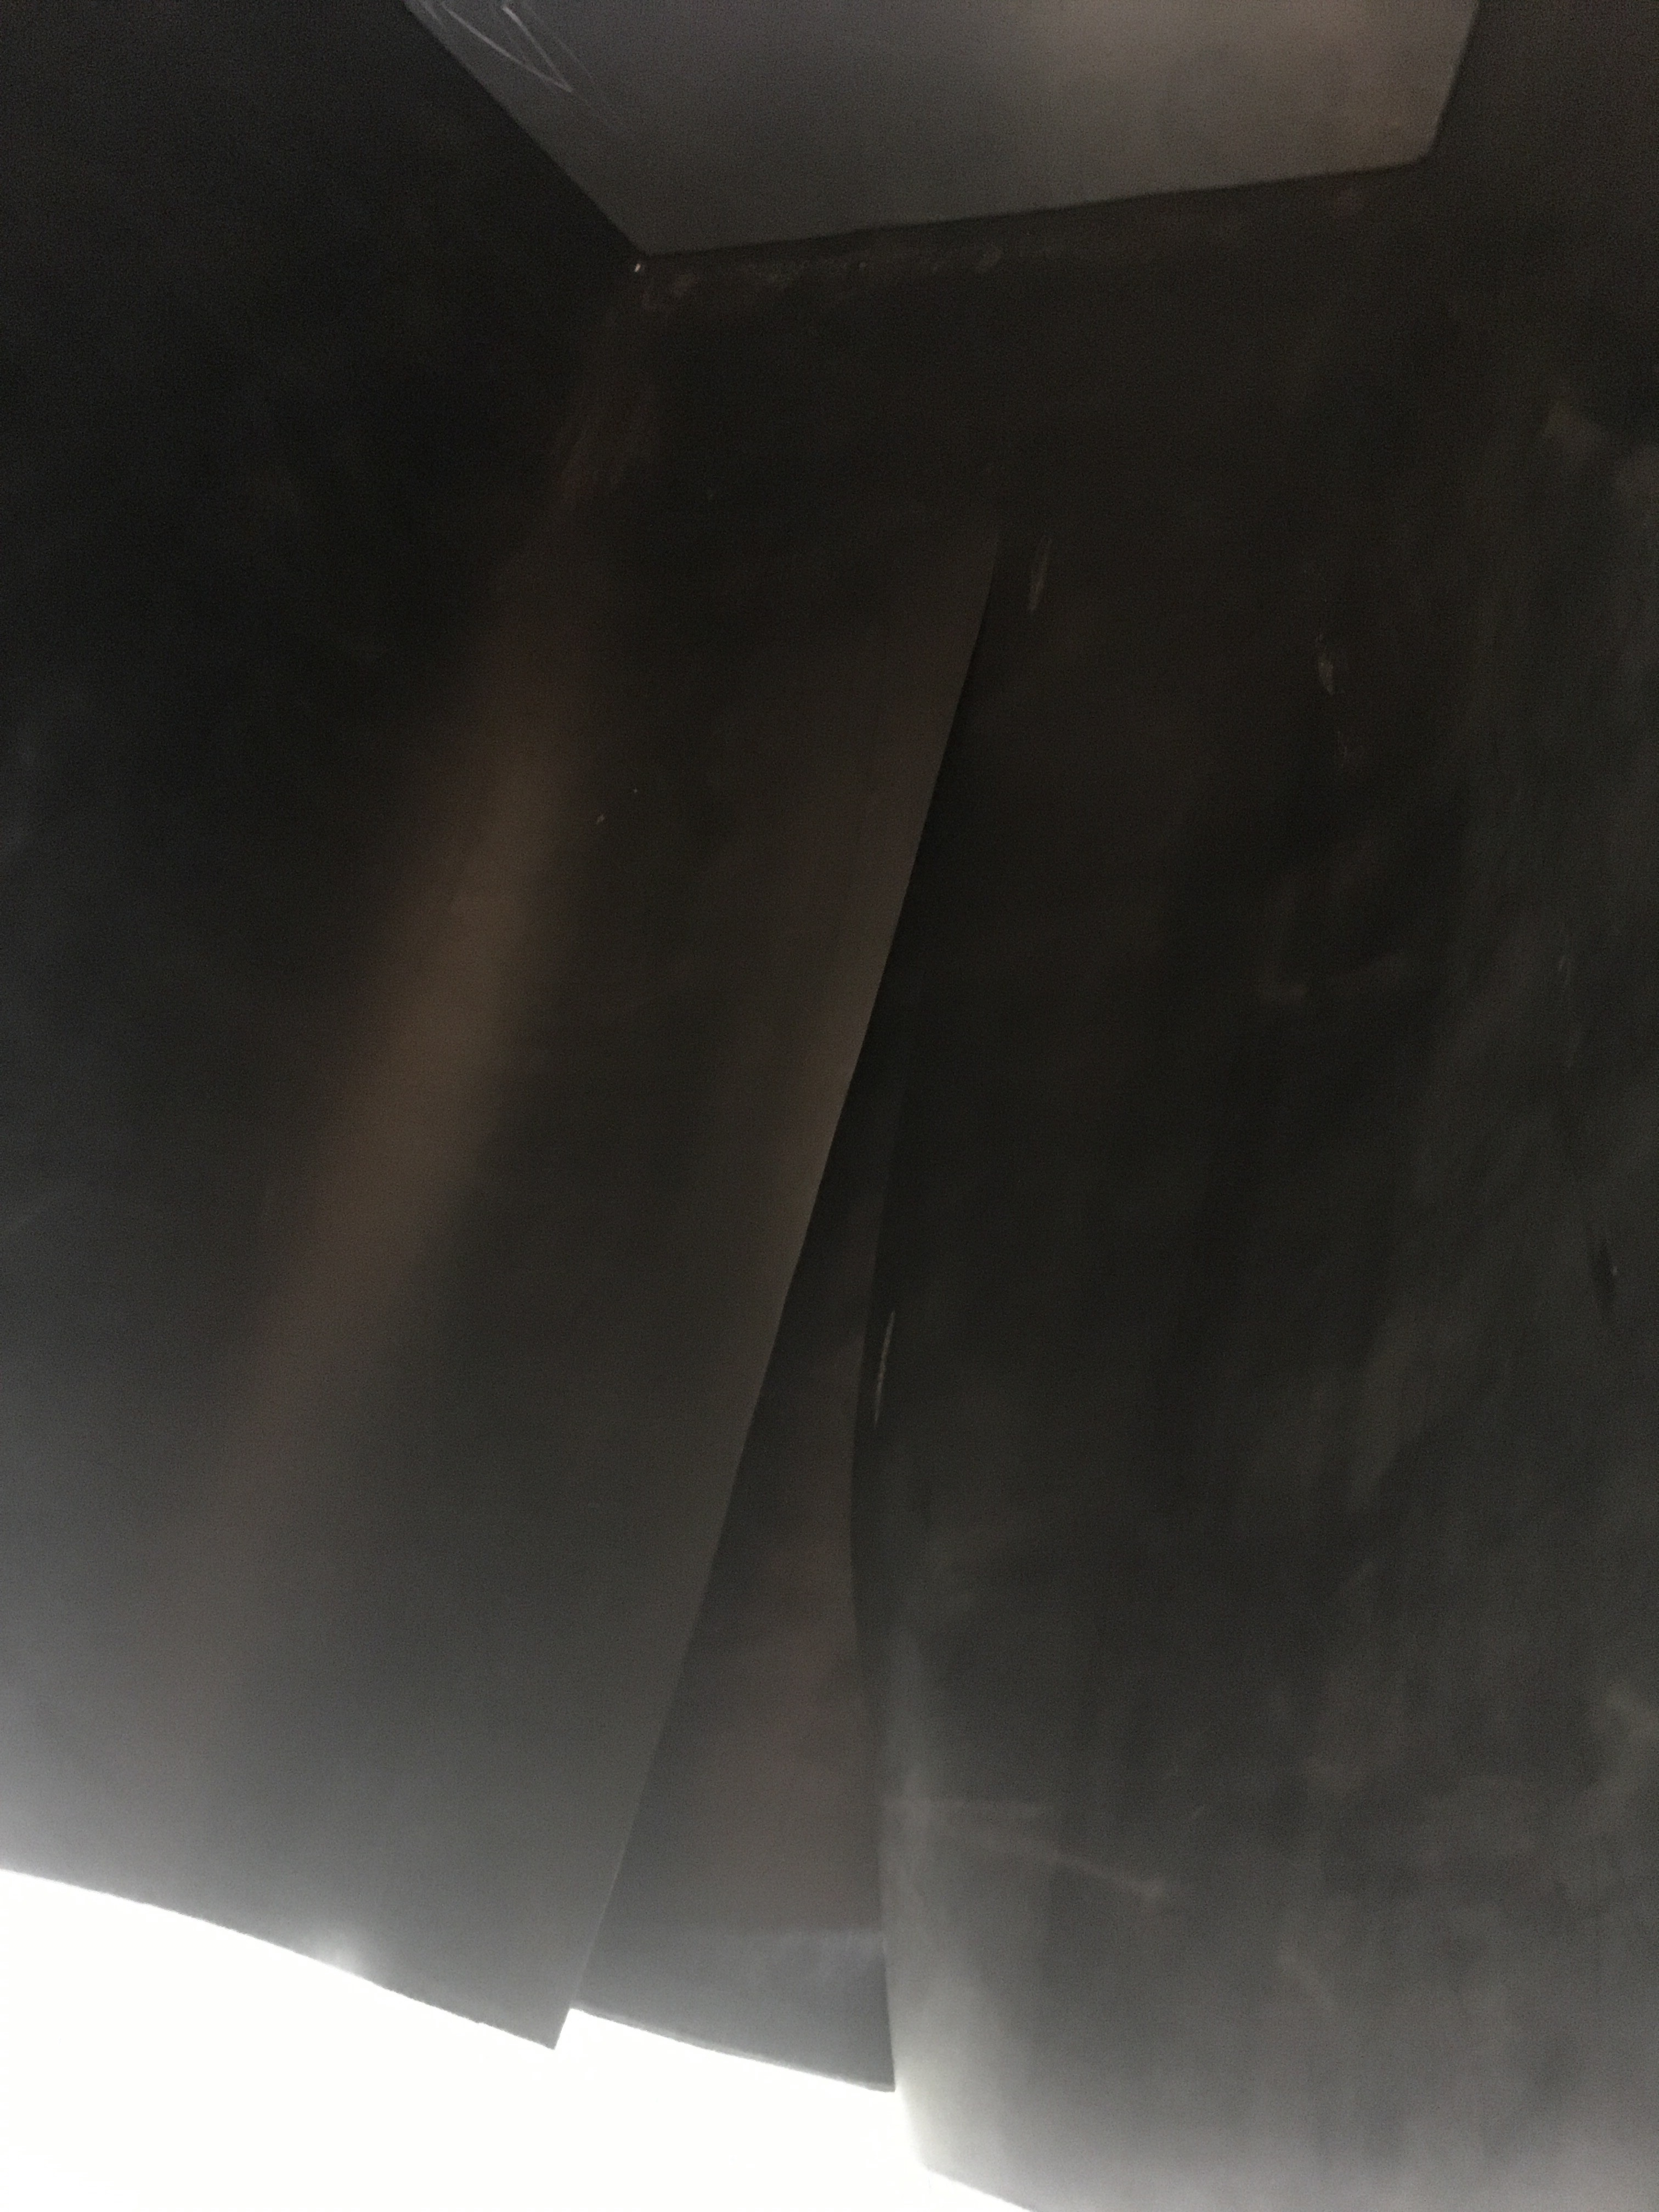
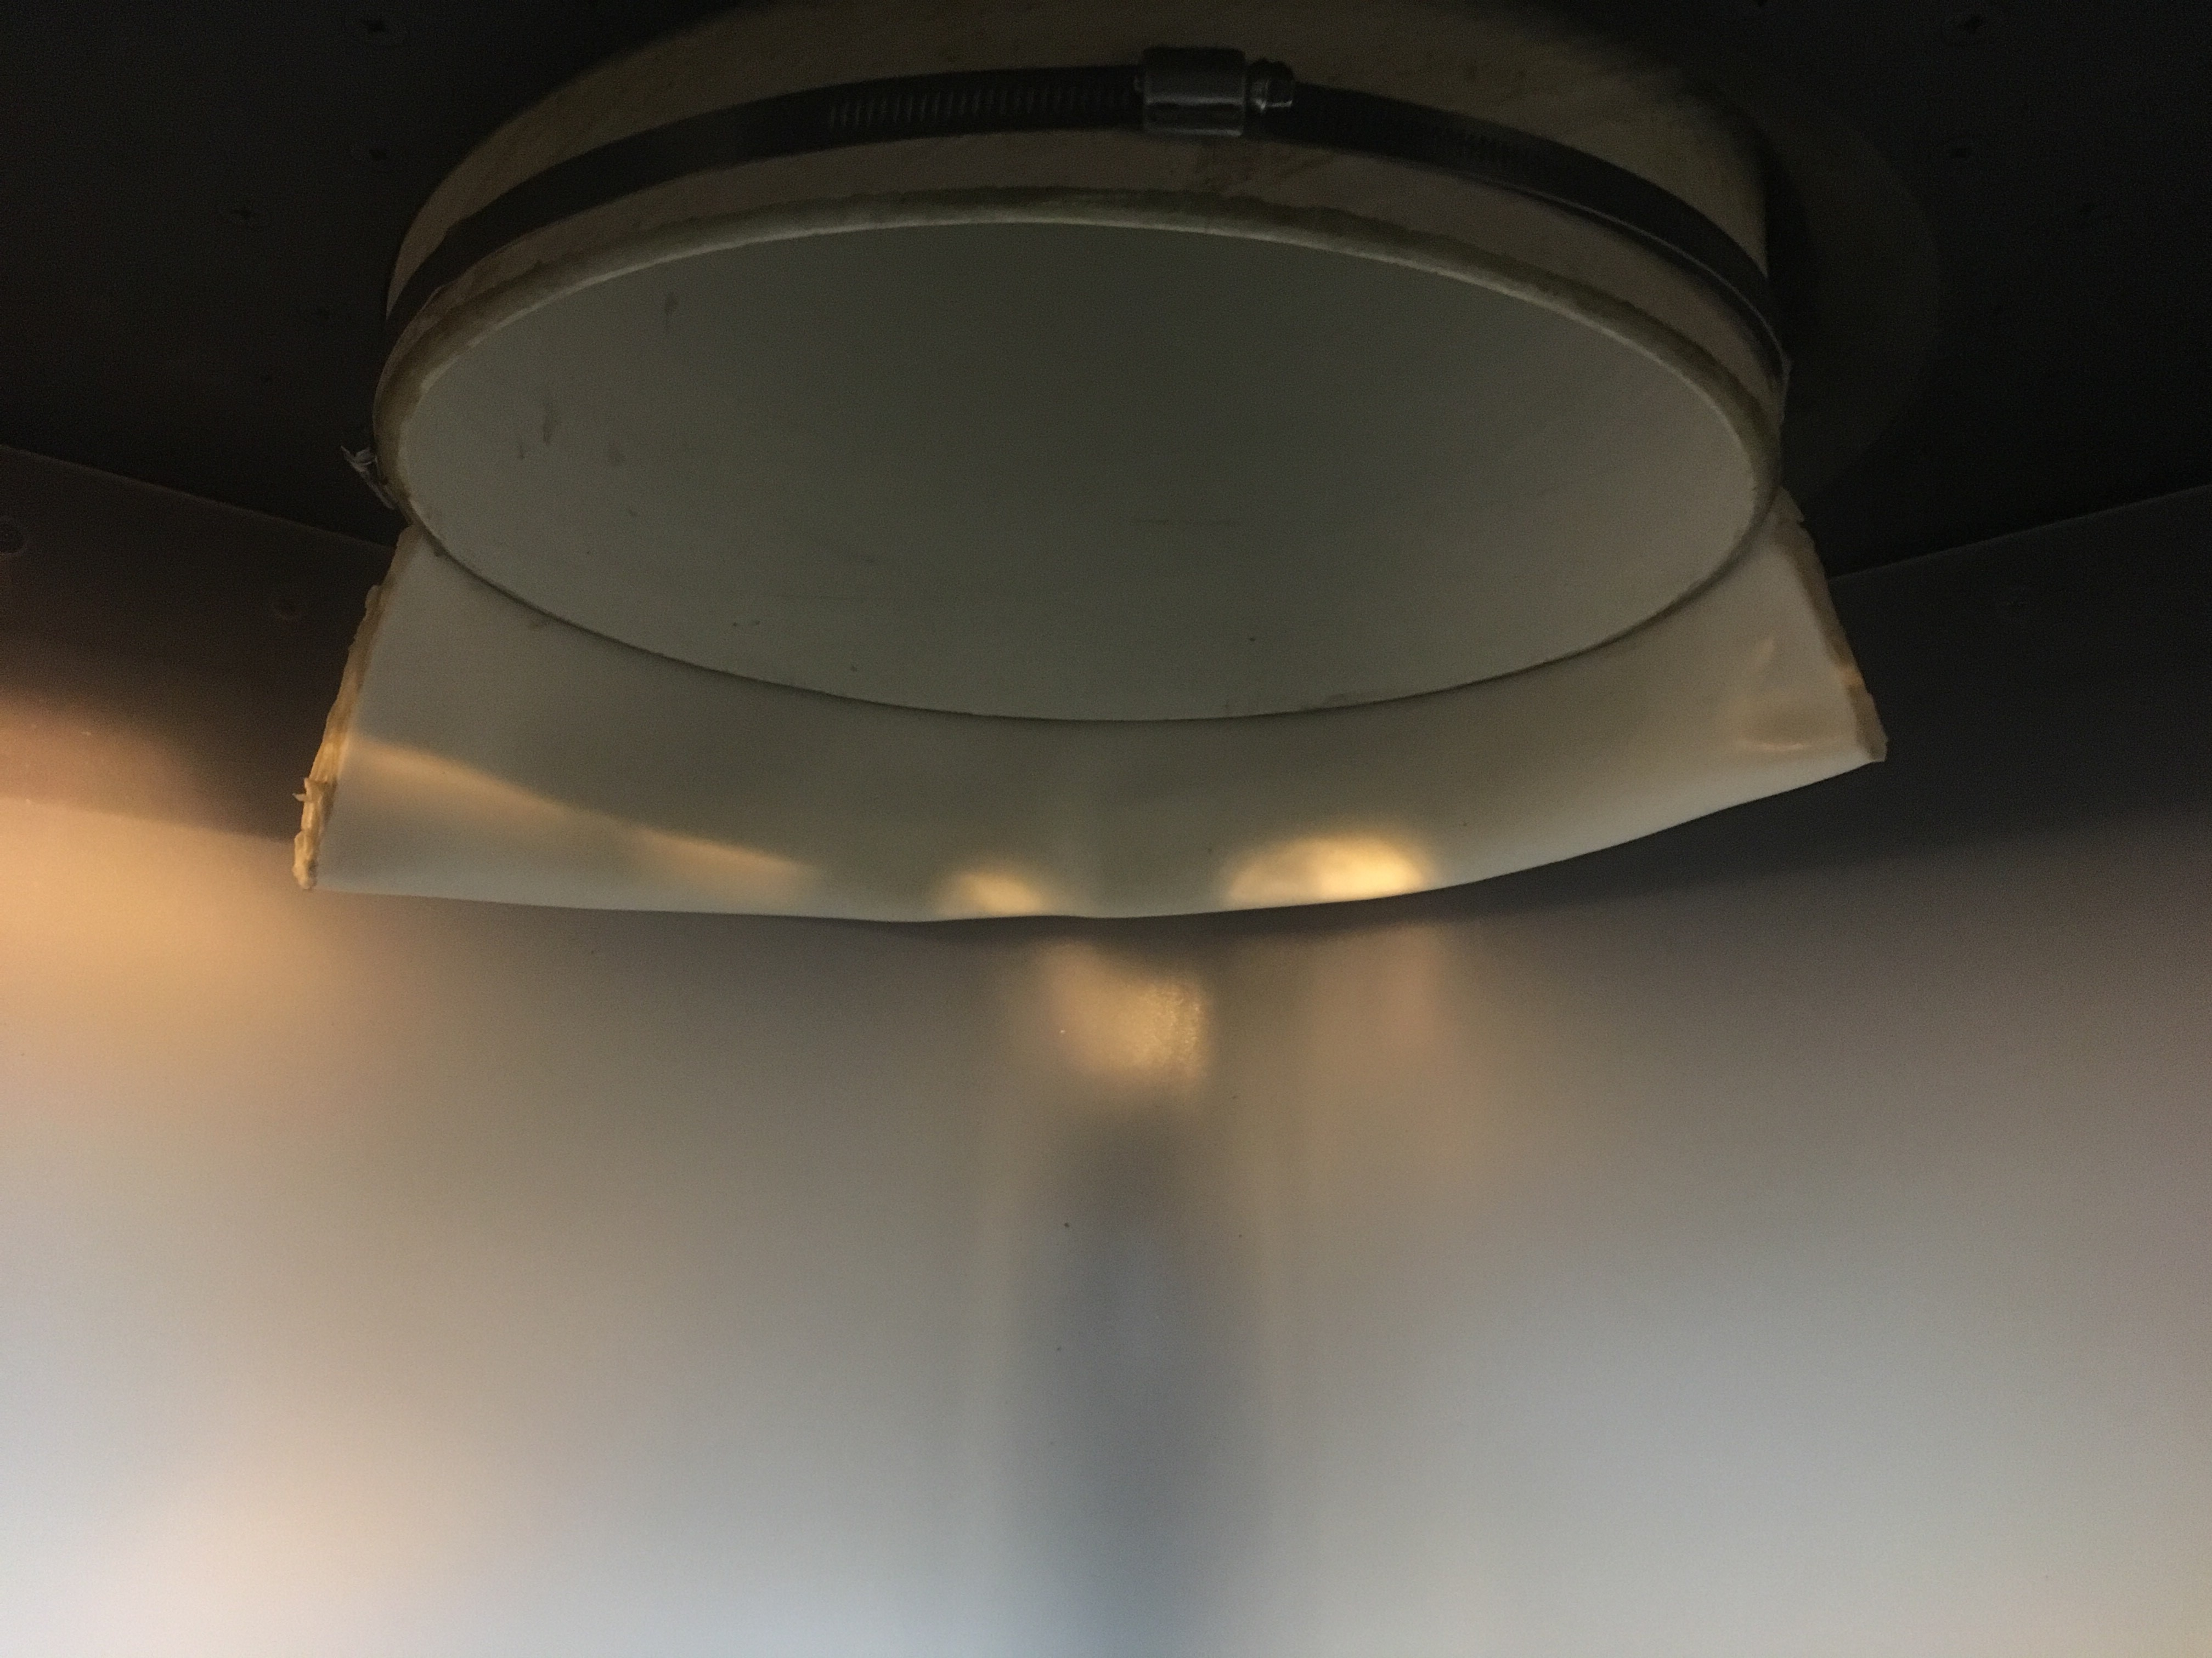
- Pipe lip

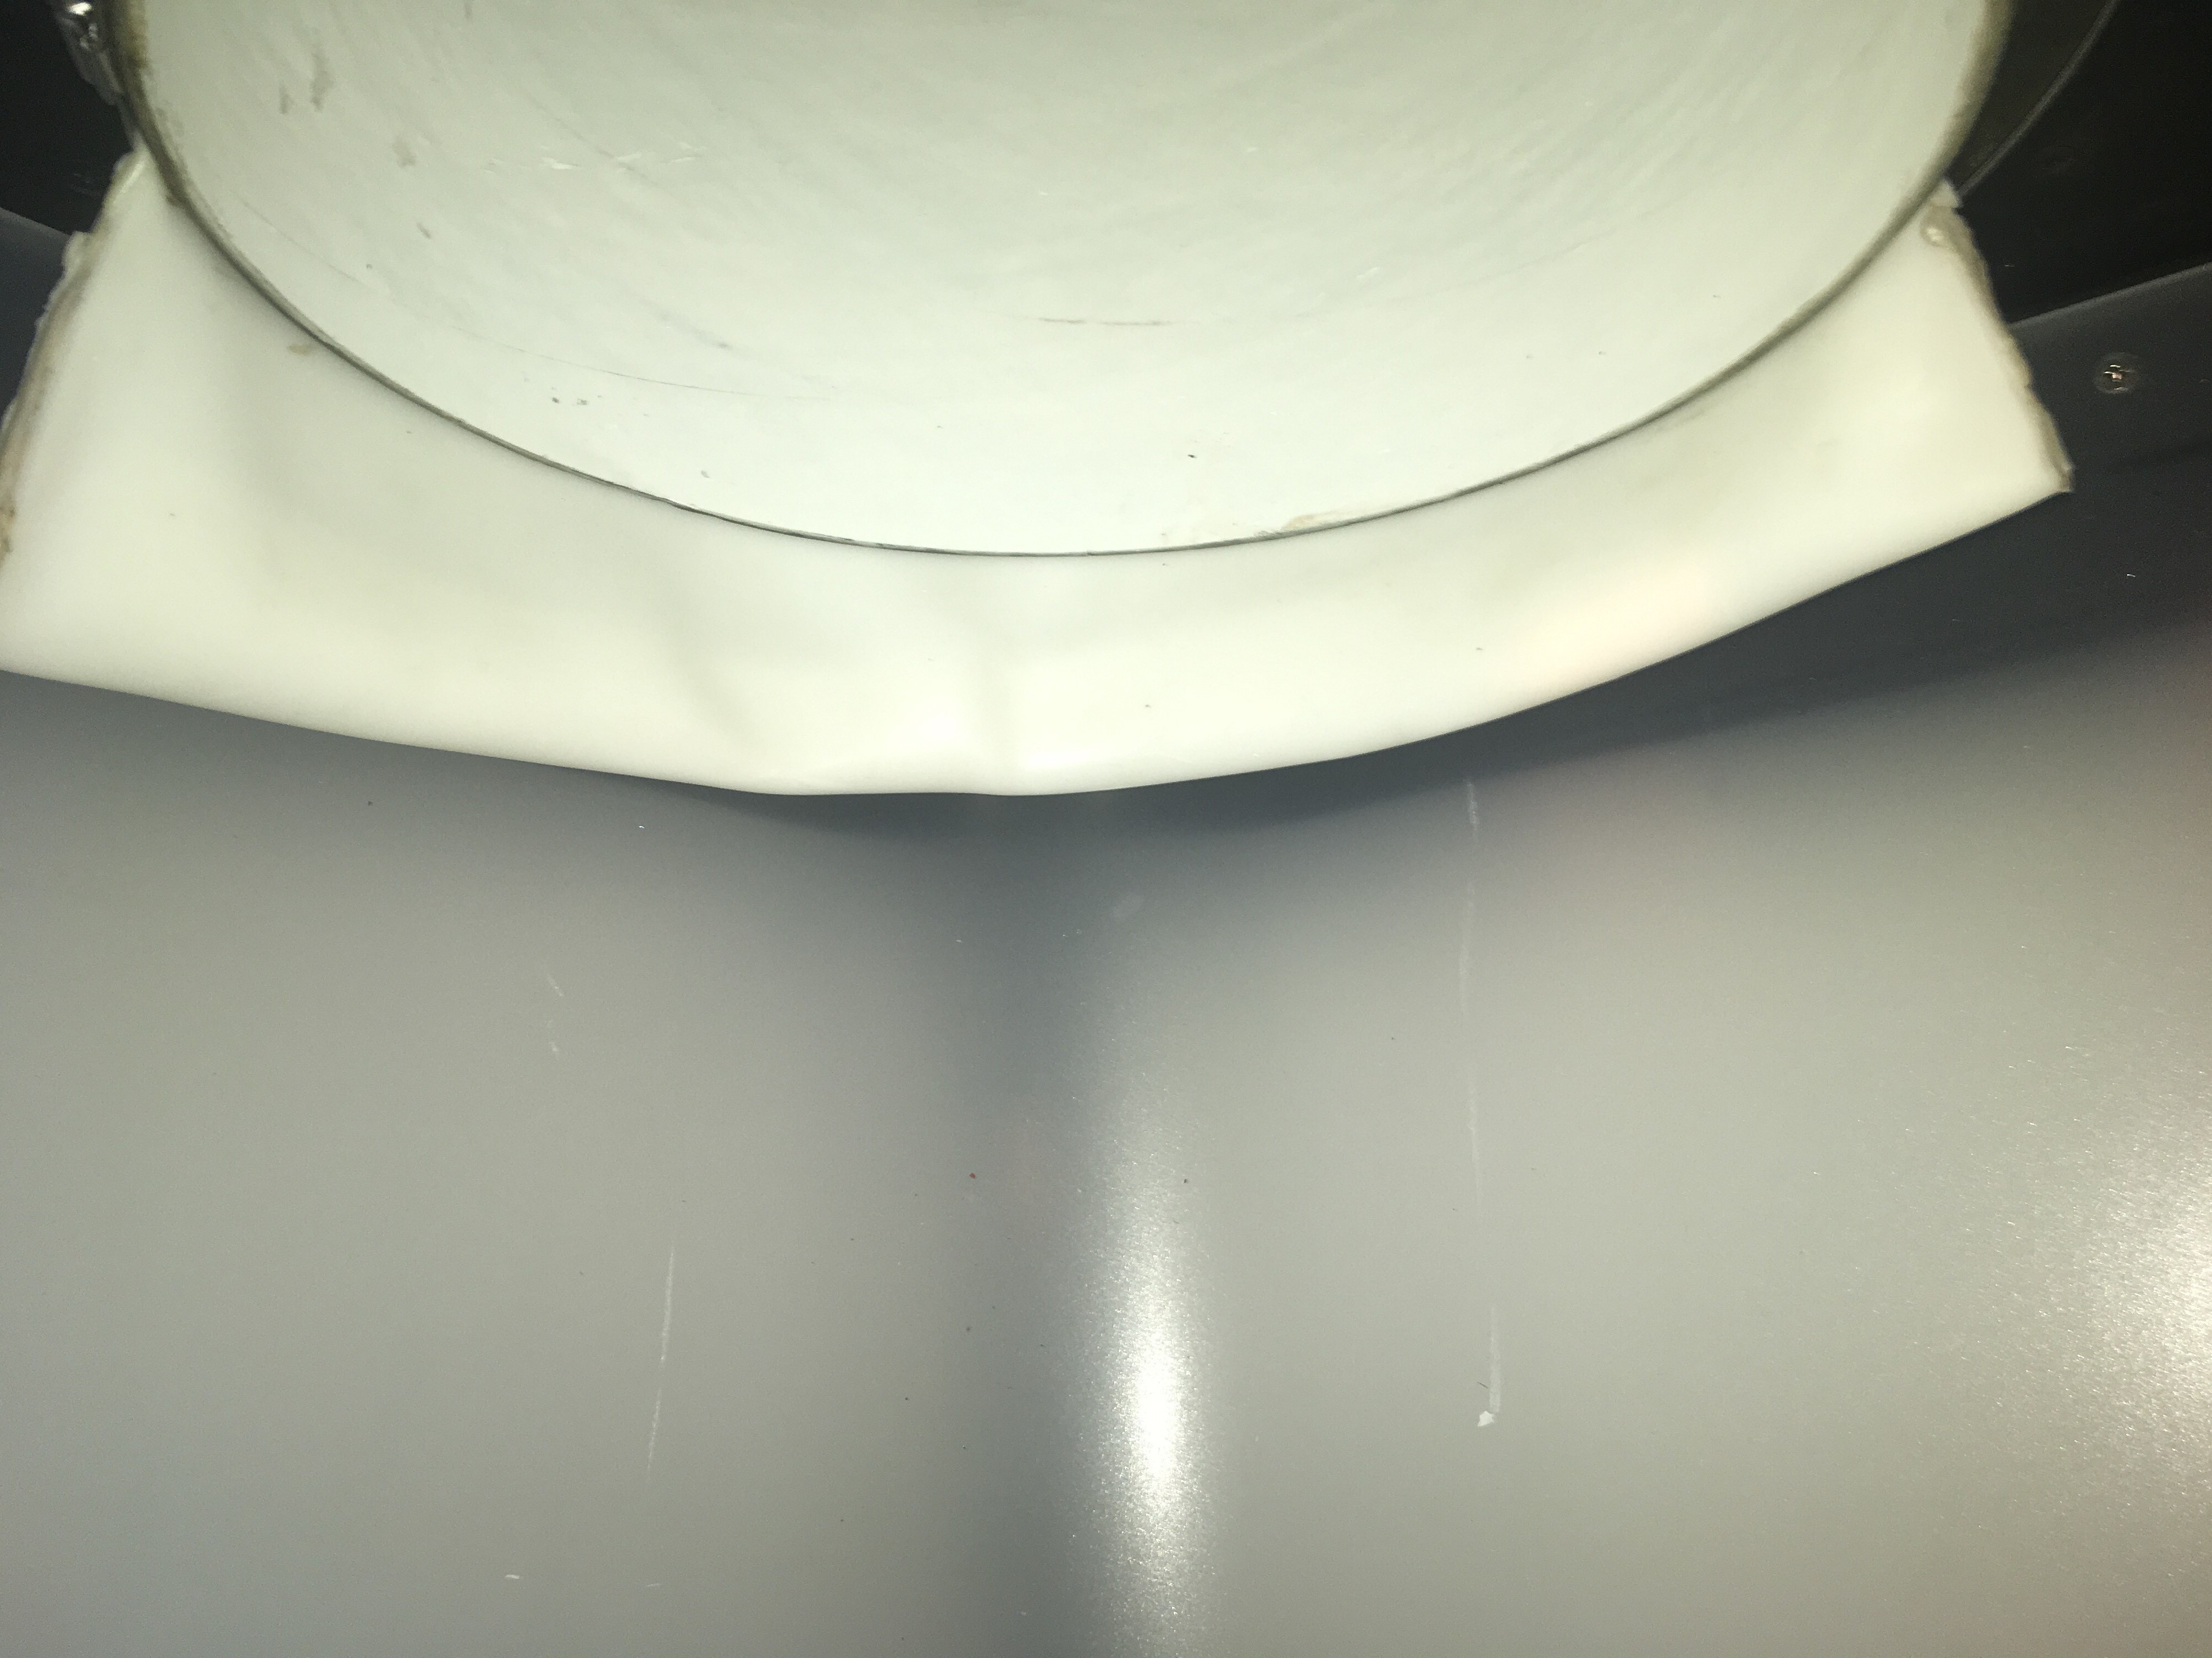
- Pipe drop

Pictures from the final modification
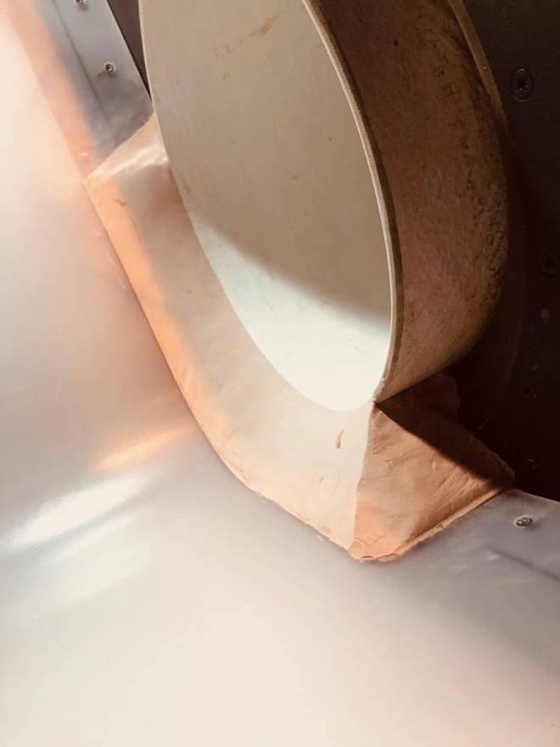
Sanded transition

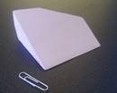
Epoxy material

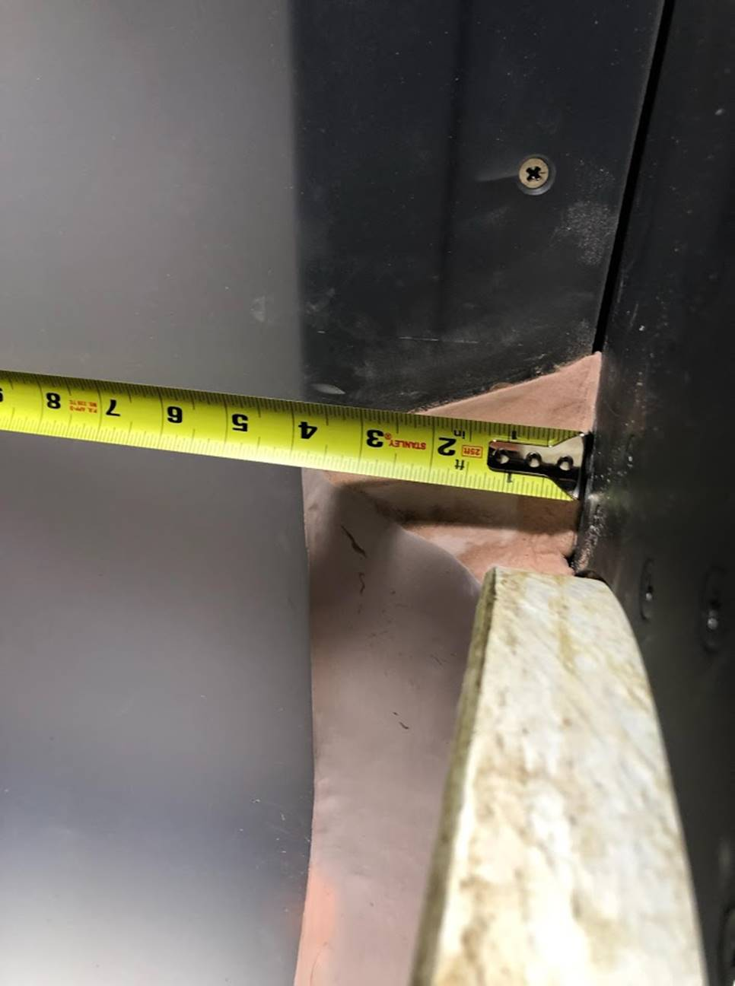
Epoxy transition with tape measure
190322 - NOAA approved the latest modification for the scanner via email.
From: Josie Thompson - NOAA Federal <josie.thompson@noaa.gov>
Sent: Friday, March 29, 2019 10:43 AM
To: dan.schneider@whooshh.com
Cc: Trevor Conder - NOAA Federal <trevor.conder@noaa.gov>; Vincent Bryan III <v3@whooshh.com>; Ritchie Graves <Ritchie.graves@noaa.gov>; Kovalchuk, Erin H NWP <Erin.H.Kovalchuk@usace.army.mil>
Subject: Re: Bonneville Scanner

Hello Dan,

Thank you for providing the requested photo (including tape measure). It is not as ideal as seeing this in person (and 3-D), but the photo appears to demonstrate that the transition now meets the agreed-upon specifications.
Under the authority granted to me by Trevor, I approve this final requirement and I believe this means that Bonneville's AFF team (and the Whoosh team) can move forward in preparing the facility for spring operations.

Please let me know if you have any additional questions or needs.

Sincerely,

Josie Thompson
Columbia Hydropower Branch
Interior Columbia Basin Office
NOAA Fisheries, West Coast Region
503-231-2313
Josie.Thompson@noaa.gov

After Action update –

Please email or call with questions or concerns.
Thank you,
Erin

Erin Kovalchuk
NWP Operations Division Fishery Section
Columbia River Coordination Biologist
Erin.H.Kovalchuk@usace.army.mil

Andrew Derugin
Fishery Biologist
Bonneville Dam
Andrew.G.Derugin@usace.army.mil

